**IP Security, Transport level security and Email Security**

**⚛IP Sec:**

* IP Sec (Internet Protocol Security) is an Internet Engineering Task Force (IETF) standard suite of protocols between two communication points across the IP network that provide data authentication, integrity, and confidentiality.
* It also defines the encrypted, decrypted, and authenticated packets.
* The protocols needed for secure key exchange and key management are defined in it.
* these components are very important in order to provide the three main services:

1. Confidentiality
2. Authentication
3. Integrity

**⚛IP Security Architecture:**

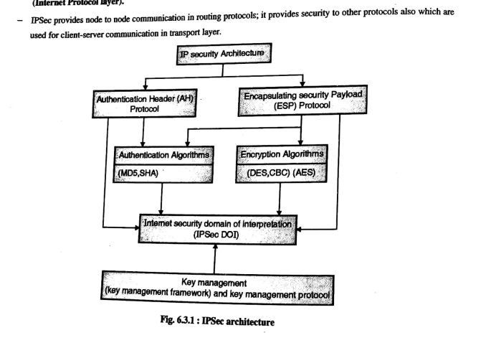

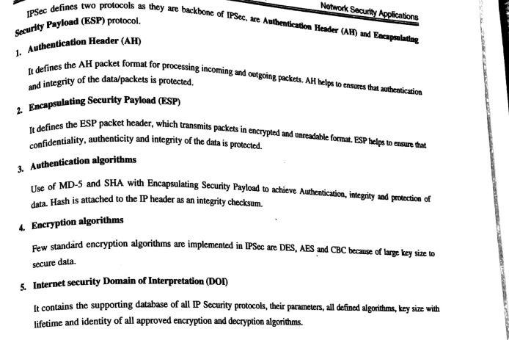

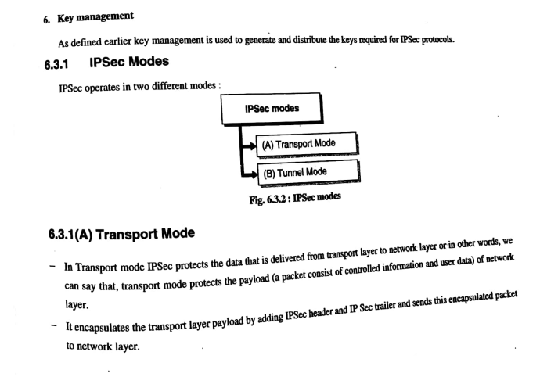

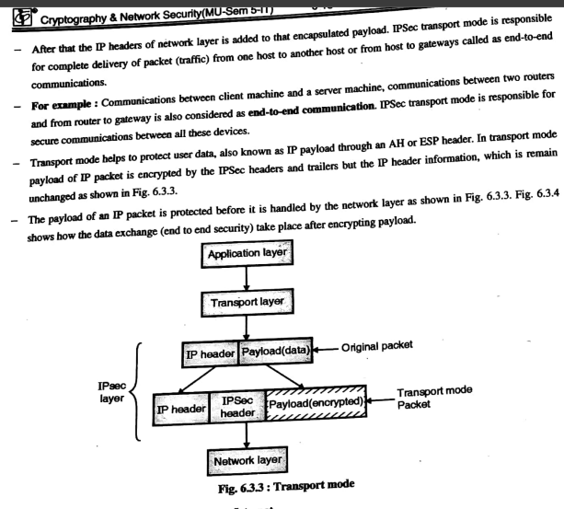

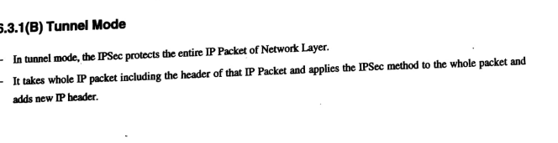 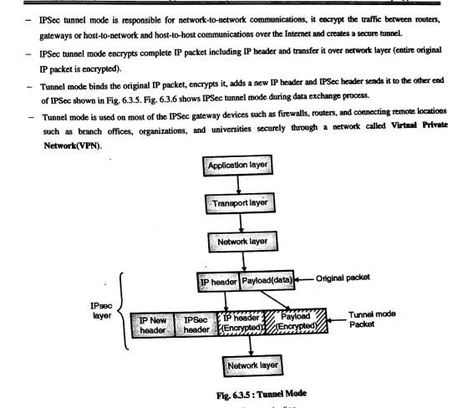

**✴Advantages of IPSec:**

* Strong security: IPSec provides strong cryptographic security services that help protect sensitive data and ensure network privacy and integrity.
* Wide compatibility: IPSec is an open standard protocol that is widely supported by vendors and can be used in heterogeneous environments.
* Flexibility: IPSec can be configured to provide security for a wide range of network topologies, including point-to-point, site-to-site, and remote access connections.
* Scalability: IPSec can be used to secure large-scale networks and can be scaled up or down as needed.

**✴Disadvantages of IPSec:**

* Configuration complexity: IPSec can be complex to configure and requires specialized knowledge and skills.
* Compatibility issues: IPSec can have compatibility issues with some network devices and applications, which can lead to interoperability problems.
* Performance impact: IPSec can impact network performance due to the overhead of encryption and decryption of IP packets.
* Key management: IPSec requires effective key management to ensure the security of the cryptographic keys used for encryption and authentication.

**☢Internet Protocol Authentication (AH)Header :**

When packet is sent from source A to Destination B, it consists of data that we need to send and header which consist of information regarding packet. Authentication Header verifies origin of data and also payload to confirm if there has been modification done in between, during transmission between source and destination.

**Authentication Header**: The question may arise, that how IP header will know that adjacent Extension header is Authentication Header. Well, there is protocol field in IP Header which tells type of header that is present in packet. So, protocol field in IP Header should have value of “51” in order to detect Authentication Header.

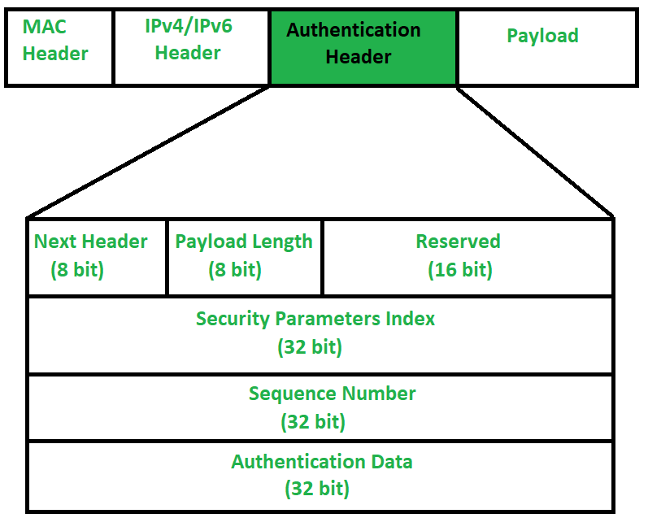

**Next Header** – Next Header is 8-bit field that identifies type of header present after Authentication Header. In case of TCP, UDP or destination header or some other extension header it will store correspondence IP protocol number . Like, number 4 in this field will indicate IPv4, number 41 will indicate IPv6 and number 6 will indicate TCP.

**Payload** **Length** – Payload length is length of Authentication header and here we use scaling factor of 4. Whatever be size of header, divide it by 4 and then subtract by 2. We are subtracting by 2 because we’re not counting first 8 bytes of Authentication header, which is first two row of picture given above. It means we are not including Next Header, Payload length, Reserved and Security Parameter index in calculating payload length. Like, say if payload length is given to be X. Then (X+2)*4 will be original Authentication header length.

**Reserved** – This is 16-bit field which is set to “zero” by sender as this field is reserved for future use.

**Security Parameter Index (SPI)** – It is arbitrary 32-bit field. It is very important field which identifies all packets which belongs to present connection. If we’re sending data from Source A to Destination B. Both A and B will already know algorithm and key they are going to use. So for Authentication, hashing function and key will be required which only source and destination will know about. Secret key between A and B is exchanged by method of Diffie Hellman algorithm. So Hashing algorithm and secret key for Security parameter index of connection will be fixed. Before data transfer starts security association needs to be established. In Security Association, both parties needs to communicate prior to data exchange. Security association tells what is security parameter index, hashing algorithm and secret key that are being used.

**Sequence Number** – This unsigned 32-bit field contains counter value that increases by one for each packet sent. Every packet will need sequence number. It will start from 0 and will go till 2^{32} – 1 and there will be no wrap around. Say, if all sequence numbers are over and none of it is left but we cannot wrap around as it is not allowed. So, we will end connection and re-establish connection again to resume transfer of remaining data from sequence number 0. Basically sequence numbers are used to stop replay attack. In Replay attack, if same message is sent twice or more, receiver won’t be able to know if both messages are sent from a single source or not. Say, I am requesting 100$ from receiver and Intruder in between asked for another 100$. Receiver won’t be able to know that there is intruder in between.

**Authentication Data** (Integrity Check Value) – Authentication data is variable length field that contains Integrity Check Value (ICV) for packet. Using hashing algorithm and secret key, sender will create message digest which will be sent to receiver. Receiver on other hand will use same hashing algorithm and secret key. If both message digest matches then receiver will accept data. Otherwise, receiver will discard it by saying that message has been modified in between. So basically, authentication data is used to verify integrity of transmission. Also length of Authentication data depends upon hashing algorithm you choose.

Modes of operations in Authentication Header:

There are two modes in the authentication header

* Authentication Header Transport Mode:
* Authentication Header Tunnel Mode:

**Authentication Header Transport Mode**: In the authentication header transport mode, it is lies between the original IP Header and IP Packets original TCP header.

**Authentication Header Tunnel Mode**: In this authentication header tunnel mode, the original IP packet is authenticated entire and the authentication header is inserted between the original IP header and new outer IP header. Here, the inner IP header contains the ultimate source IP address and destination IP address. whereas the outer IP header contains different IP address that is IP address of the firewalls or other security gateways.

**☣Secure Socket Layer Protocols:**

* Secure Socket Layer (SSL) provides security to the data that is transferred between web browser and server.
* SSL encrypts the link between a web server and a browser which ensures that all data passed between them remain private and free from attack.
* Secure Sockets Layer (SSL) is a standard technique for transmitting documents securely across a network. SSL technology, created by Netscape, establishes a secure connection between a Web server and a browser, ensuring private and secure data transmission.
* SSL communicates using the Transport Control Protocol (TCP).
* The term "socket" in SSL refers to the method of sending data via a network between a client and a server.
* SSL record protocol
* Handshake protocol
* Change-cipher spec protocol
* Alert protocol

**Salient Features of Secure Socket Layer:**

* The advantage of this approach is that the service can be tailored to the specific needs of the given application.
* Secure Socket Layer was originated by Netscape.
* SSL is designed to make use of TCP to provide reliable end-to-end secure service.
* This is a two-layered protocol.

**SSL Protocol Stack:**

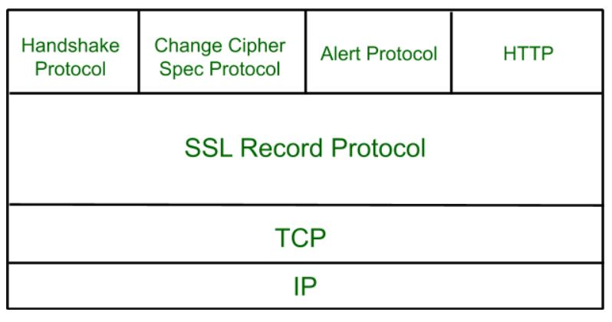

**SSL Record Protocol:**

SSL Record provides two services to SSL connection.

* Confidentiality
* Message Integrity

In the SSL Record Protocol application data is divided into fragments.

The fragment is compressed and then encrypted MAC (Message Authentication Code) generated by algorithms like SHA (Secure Hash Protocol) and MD5 (Message Digest) is appended.

After that encryption of the data is done and in last SSL header is appended to the data.

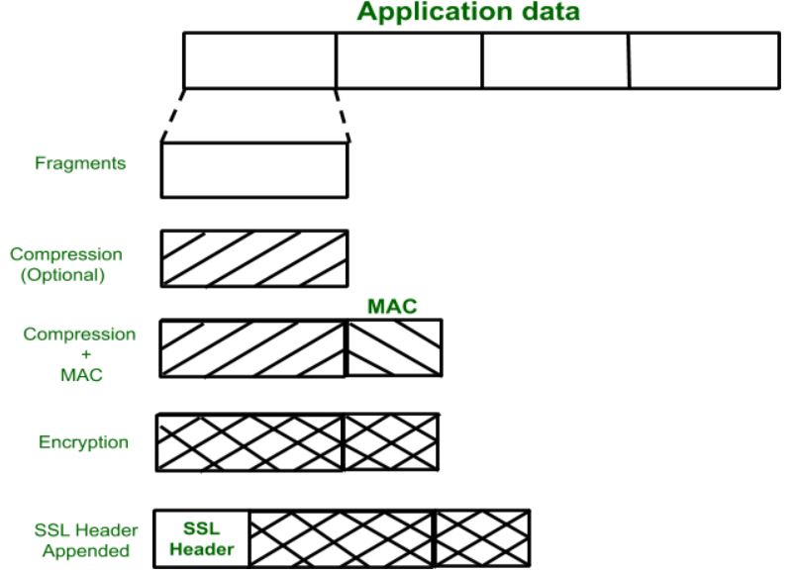

**🔅Handshake Protocol:**

Handshake Protocol is used to establish sessions. This protocol allows the client and server to authenticate each other by sending a series of messages to each other. Handshake protocol uses four phases to complete its cycle.

* Phase-1: In Phase-1 both Client and Server send hello-packets to each other. In this IP session, cipher suite and protocol version are exchanged for security purposes.
* Phase-2: Server sends his certificate and Server-key-exchange. The server end phase-2 by sending the Server-hello-end packet.
* Phase-3: In this phase, Client replies to the server by sending his certificate and Client-exchange-key.
* Phase-4: In Phase-4 Change-cipher suite occurs and after this the Handshake Protocol ends.

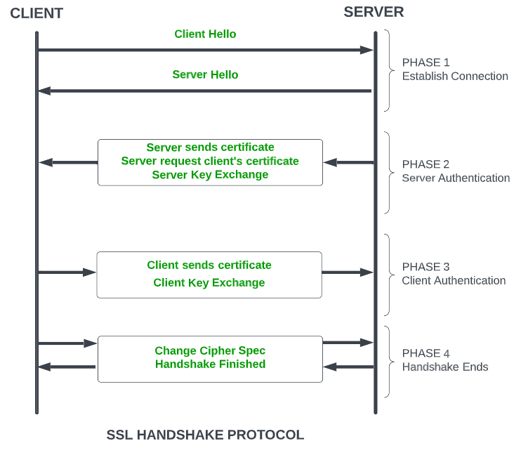

**Change-cipher Protocol:**

This protocol uses the SSL record protocol. Unless Handshake Protocol is completed, the SSL record Output will be in a pending state. After the handshake protocol, the Pending state is converted into the current state.

Change-cipher protocol consists of a single message which is 1 byte in length and can have only one value. This protocol’s purpose is to cause the pending state to be copied into the current state.



**Alert Protocol:**

This protocol is used to convey SSL-related alerts to the peer entity. Each message in this protocol contains 2 bytes.

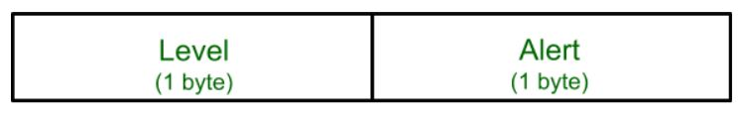

**Versions of SSL:**

* SSL 1 – Never released due to high insecurity.
* SSL 2 – Released in 1995.
* SSL 3 – Released in 1996.
* TLS 1.0 – Released in 1999.
* TLS 1.1 – Released in 2006.
* TLS 1.2 – Released in 2008.
* TLS 1.3 – Released in 2018

SSL (Secure Sockets Layer) certificate is a digital certificate used to secure and verify the identity of a website or an online service. The certificate is issued by a trusted third-party called a Certificate Authority (CA), who verifies the identity of the website or service before issuing the certificate.

The SSL certificate has several important characteristics that make it a reliable solution for securing online transactions:

1. **Encryption**: The SSL certificate uses encryption algorithms to secure the communication between the website or service and its users. This ensures that the sensitive information, such as login credentials and credit card information, is protected from being intercepted and read by unauthorized parties.
2. **Authentication**: The SSL certificate verifies the identity of the website or service, ensuring that users are communicating with the intended party and not with an impostor. This provides assurance to users that their information is being transmitted to a trusted entity.
3. **Integrity**: The SSL certificate uses message authentication codes (MACs) to detect any tampering with the data during transmission. This ensures that the data being transmitted is not modified in any way, preserving its integrity.
4. **Non**-**repudiation**: SSL certificates provide non-repudiation of data, meaning that the recipient of the data cannot deny having received it. This is important in situations where the authenticity of the information needs to be established, such as in e-commerce transactions.
5. **Public**-**key** **cryptography**: SSL certificates use public-key cryptography for secure key exchange between the client and server. This allows the client and server to securely exchange encryption keys, ensuring that the encrypted information can only be decrypted by the intended recipient.

**🦁Secure Shell (SSH) Protocol Stack:**

* SSH stands for Secure Shell or Secure Socket Shell.
* It is a cryptographic network protocol that allows two computers to communicate and share the data over an insecure network such as the internet.
* It is used to login to a remote server to execute commands and data transfer from one machine to another machine.
* The SSH protocol was developed by SSH communication security Ltd to safely communicate with the remote machine.
* Secure communication provides a strong password authentication and encrypted communication with a public key over an insecure channel.
* It is used to replace unprotected remote login protocols **such as Telnet, rlogin, rsh, etc**., and insecure file transfer protocol FTP.
* Its security features are widely used by network administrators for managing systems and applications remotely.
* The SSH protocol protects the network from various attacks such as DNS spoofing, IP source routing, and IP spoofing.

**How does SSH Works?**

The SSH protocol works in a client-server model, which means it connects a secure shell client application (End where the session is displayed) with the SSH server (End where session executes).

As discussed above, it was initially developed to replace insecure login protocols such as Telnet, rlogin, and hence it performs the same function.

The basic use of SSH is to connect a remote system for a terminal session and to do this, following command is used:

ssh UserName@SSHserver.test.com

If we are connecting for the first time, it will prompt the remote host's public key fingerprint and ask to connect.

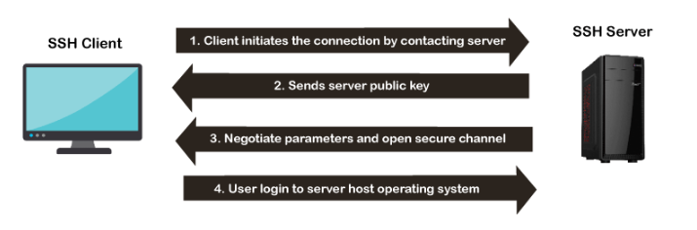

**The architecture of SSH Protocol**

The SSH architecture is made-up of three well-separated layers. These layers are:

1. Transport Layer
2. User-authentication layer
3. Connection Layer

**SSH Encryption Techniques**

To make a secure transmission, SSH uses three different encryption techniques at various points during a transmission. These techniques are:

1. Symmetrical Encryption
2. Asymmetrical Encryption
3. Hashing

**Usages of SSH protocol**

The popular usages of SSH protocol are given below:

* It provides secure access to users and automated processes.
* It is an easy and secure way to transfer files from one system to another over an insecure network.
* It also issues remote commands to the users.
* It helps the users to manage the network infrastructure and other critical system components.
* It is used to log in to shell on a remote system (Host), which replaces Telnet and rlogin and is used to execute a single command on the host, which replaces rsh.

**🐥Email security**

Email security refers to the steps where we protect the email messages and the information that they contain from unauthorized access, and damage. It involves ensuring the confidentiality, integrity, and availability of email messages, as well as safeguarding against phishing attacks, spam, viruses, and another form of malware. It can be achieved through a combination of technical and non-technical measures.

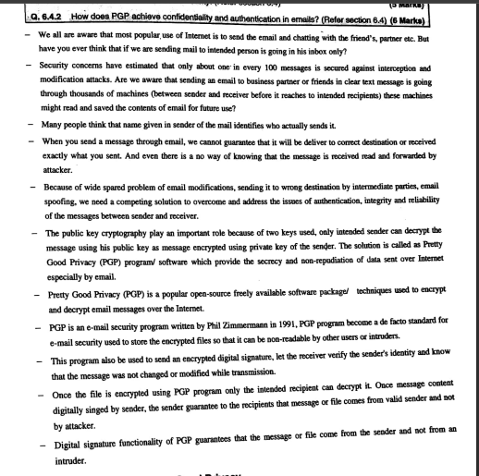

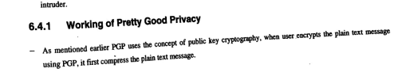

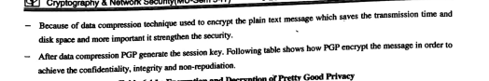

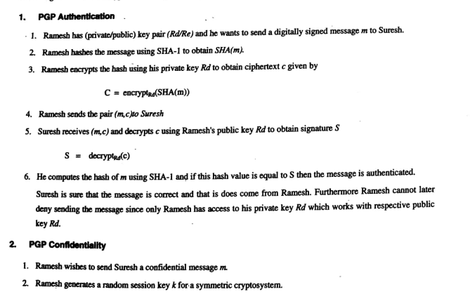

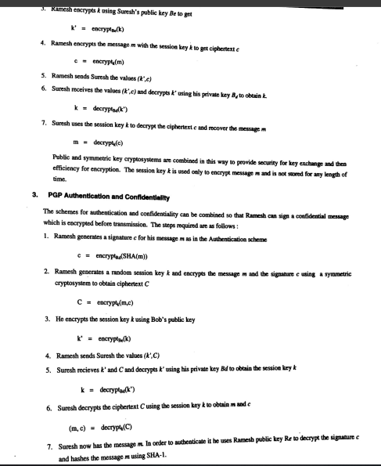

**🐧MIME :**

MIME stands for Multipurpose Internet Mail Extensions. It is used to extend the capabilities of Internet e-mail protocols such as SMTP. The MIME protocol allows the users to exchange various types of digital content such as pictures, audio, video, and various types of documents and files in the e-mail. MIME was created in 1991 by a computer scientist named Nathan Borenstein at a company called Bell Communications.

**Need of MIME Protocol**

MIME protocol is used to transfer e-mail in the computer network for the following reasons:

* The MIME protocol supports multiple languages in e-mail, such as Hindi, French, Japanese, Chinese, etc.
* Simple protocols can reject mail that exceeds a certain size, but there is no word limit in MIME.
* Images, audio, and video cannot be sent using simple e-mail protocols such as SMTP. These require MIME protocol.
* Many times, emails are designed using code such as HTML and CSS, they are mainly used by companies for marketing their product. This type of code uses MIME to send email created from HTML and CSS.

**S/MIME?**

Secure/Multipurpose Internet Mail Extension (S/MIME) is an industry-standard for email encryption and signature that is commonly used by businesses to improve email security. S/MIME is supported by the majority of corporate email clients.

S/MIME encrypts and digitally signs emails to verify that they are verified and that their contents have not been tampered with.

**S/MIME Certificate Characteristics**

You receive a slew of cryptographic security features when you use an S/MIME certificate for email apps.

1. **Authentication** − It refers to the verification of a computer user's or a website's identity.
2. **Message consistency** − This is a guarantee that the message's contents and data have not been tampered with. The message's secrecy is crucial. The decryption procedure entails checking the message's original contents and guaranteeing that they have not been altered.
3. **Use of digital signatures that invoke non-repudiation** − This is a circumstance in which the original sender's identity and digital signatures are validated so that there is no doubt about it.
4. **Protection of personal information** − A data breach cannot be caused by an unintentional third party.
5. **Encryption is used to protect data** − It relates to the procedures described above, in which data security is ensured by a mix of public and private keys representing asymmetric cryptography.

**Support for S/MIME:**

Some of the most popular email programs that support S/MIME are listed below.

* iPhone iOS Mai
* Apple Mail
* Gmail IBM Notes
* Mozilla Thunderbird MailMate Microsoft Outlook or Outlook on the Web
* CipherMail

**Features of MIME Protocol:**

* It supports multiple attachments in a single e-mail.
* It supports the non-ASCII characters.
* It supports unlimited e-mail length.
* It supports multiple languages.

**Advantage of the MIME:**

* The MIME protocol has the following advantages:
* It is capable of sending various types of files in a message, such as text, audio, video files.
* It also provides the facility to send and receive emails in different languages like Hindi, French, Japanese, Chinese etc.
* It is capable of sending the information contained in an email regardless of its length.
* It assigns a unique id to all e-mails.